ASSIGNMENT LINK

<https://us3.ca.analytics.ibm.com/bi/?perspective=explore&pathRef=.my_folders%2FAssignment1%2Bpradesh&subView=model0000018364cc58e1_00000004>

R&D SPENDING

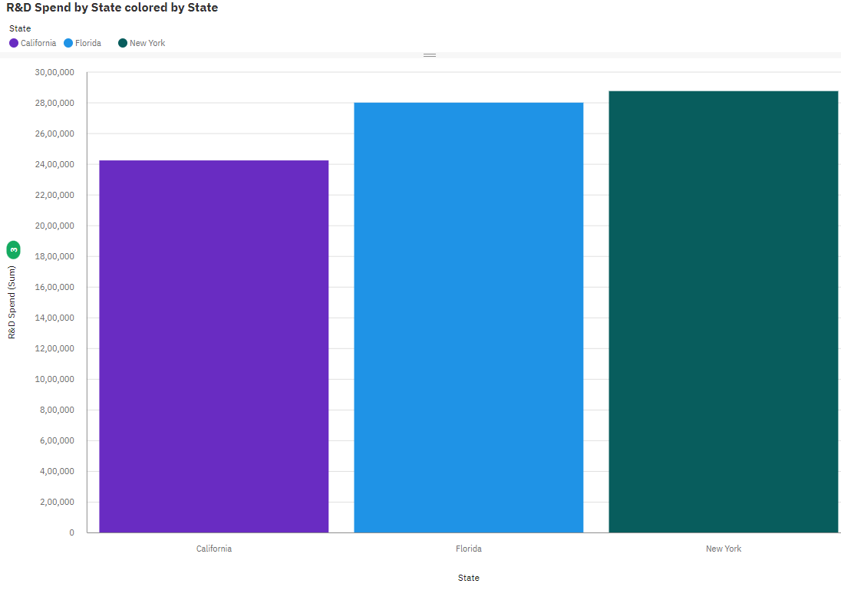

ADMINISTATION SPENDING



MARKETING SPENDING STATE

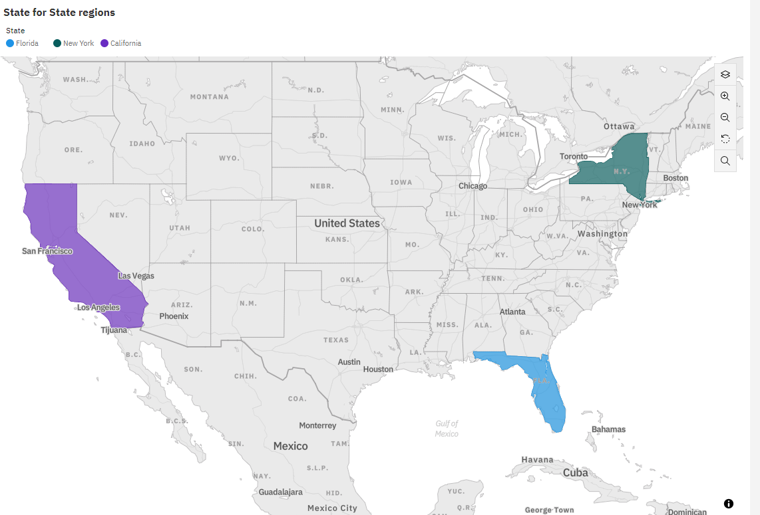

PROFIT

